**Create Flask App**

|  |  |
| --- | --- |
| Date | 27 October 2022 |
| Team ID | PNT2022TMID24193 |
| Project Name | Inventory Management System For Retailers |

**Code**

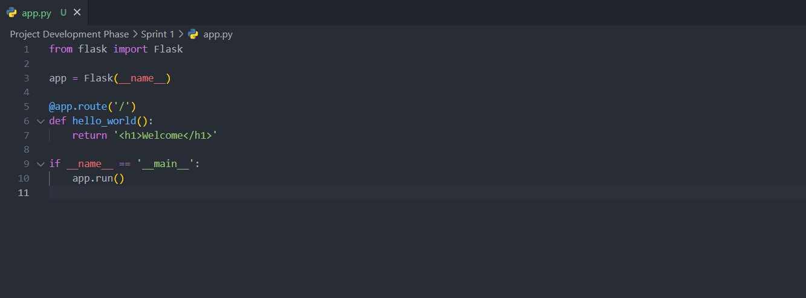

**Output**

